University of Maryland, Baltimore County
Department of Information Systems
Anish Kandel
MGMT 489 - Independent Study
Dr. Karen Chen
November 19, 2025
Case Study 3: A Data Storytelling Approach to Spotify’s Music Landscape

Source 1:
Econsultancy – “Six Insightful Data Storytelling Case Studies”
https://econsultancy.com/six-insightful-data-storytelling-case-studies/

Source 2:
Kaggle – Spotify Tracks Dataset:
https://www.kaggle.com/datasets/maharshipandya/-spotify-tracks-dataset
Business Context

The Econsultancy article “Six Insightful Data Storytelling Case Studies” illustrates how various businesses, including charities such as Marie Curie, retailers like Topshop and Homebase, and B2B companies like Farnell element14, leverage data not only for reporting but also to enhance personalization, make informed decisions, and foster more standard customer experiences. The common theme in these examples is that data gains strength when it's transcribed into a narrative with a defined audience and objective, rather than merely existing as a dashboard or table.

Starting from that objective, I aimed for Case Study 3 to implement the same concept of data storytelling, but within a different field than the first two case studies. The goal was to analyze famous data-intensive sectors that heavily rely on digital data, such as streaming, e-commerce, and digital media. Therefore, I selected Spotify and music streaming as my focal point. Spotify is well-suited as it intercepts the crossroads of technology, culture, and data where each stream, skip, and save generates insights into how individuals engage with music.

Rather than examining one marketing campaign like those presented in the Econsultancy piece, this case study utilizes a publicly accessible Spotify audio-features dataset to analyze listening habits on a large scale. The dataset features track-level attributes like genre, popularity, energy, danceability, mood valence, tempo, and length. In analyzing this data, I aimed to comply with the principle emphasized in the article. It mentions about transforming a sizable and unstructured dataset into a narrative that reveals trends, helps in decision-making, and simplifies the numbers for non-technical audiences.

In this context, this case study represents my interpretation of a “data storytelling case study” influenced by Econsultancy’s model, but tailored to the music streaming industry, which is not only a well-known business but also critically important for data-informed decisions regarding personalization and product development.

Communication Goals

The communication goal of this case study is to illustrate how large digital data can be transformed into a meaningful narrative through effective storytelling. I don't aim to predict any individual music taste or behavior. Through this dataset, the goal is to illustrate how patterns and trends in genres, mood, popularity, etc. can be visualized to make informed business decisions, product personalization, and optimization.
This analysis aims to move beyond the raw data and answer some insightful questions regarding music choices, influence behavior, and attention span across the platform. The ultimate goal is to show that raw data can be presented as a narrative that is easier to understand and visualize.
Audience

The target audience for this case study is Product managers, marketing teams, and data analysts who work in digital media and streaming platforms. Artists, record labels, and content creators who wish to learn more about the relationship between track attributes and listener interaction will also find it useful. This is also useful for Students and non-technical audiences who want to see how complicated datasets may be transformed into understandable visual narratives.

Key Story Elements

The case study is structured around some simple elements that follow the data storytelling emphasized in the article:

- Context: Streaming Platforms like Spotify generate vast amounts of raw data, which alone do not explain users' listening patterns.
- Exploration: We can examine genre mode and audio features from the data and understand how listeners interact with music.
- Insights: The audience can visualize certain patterns like sound profiles and emotional tones
- Implication: these insights are useful to make informed business decisions, product optimization, and personalization.

Data and visualization

For this case study, I used a publicly accessible Spotify data set that includes popularity measures and track-level audio attributes. I walked with a pre-structured data set and focused on choosing quantifiable factors for analysis rather than generating a new data set. The visualizations were made using Jupyter notebook to understand and analyze Trends across genres, mood, and popularity level. Rather than using sophisticated models, High prioritized clarity and interpretability using the same methodology as in the article; each graph was created to answer a particular query and a broader narrative. Request more than just complex Analytics; it also needs careful framing and presentation

Q1. What sound characteristics define the most common music genres on Spotify?
Visualization: Average Energy & Danceability by Top 10 Genres
The average energy and danceability scores for the 10 most popular Spotify genres are showed in this graph. It shows that genres such as alternative, alt-rock, afrobeat, and anime consistently score high on energy, while genres like acoustic and ambient are noticeably lower. The similar but distinct pattern of danceability suggests that upbeat music isn't necessarily intended for movement or rhythm-based interaction.

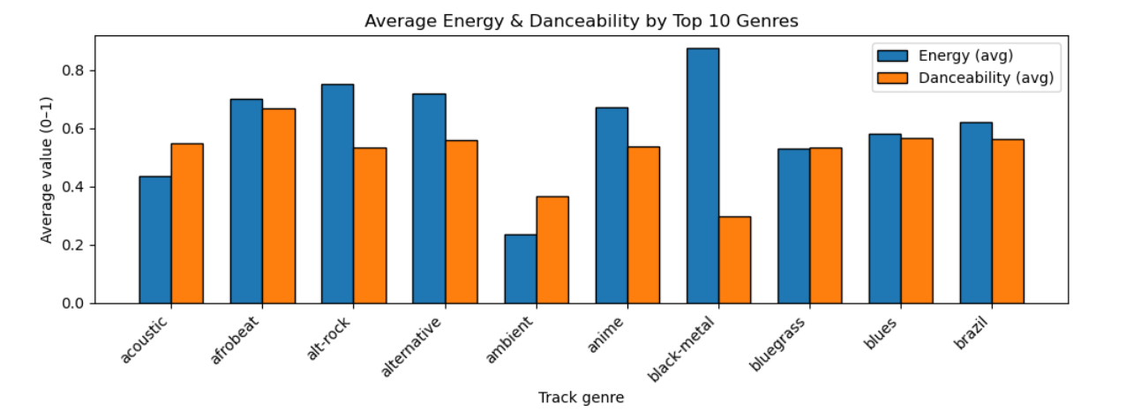

Interpretation:
This implies that genres are groups of similar sound features rather than merely stylistic names. From a business standpoint, Spotify may leverage this analysis to enhance playlist suggestions They can perhaps classify the songs according to listening context (exercise, relaxation, attention) rather than just genre. This is consistent with the growing trend of consumers using music as a utilitarian experience rather than following a rigid genre identity.

Q2. Which music genres achieve the highest listener popularity overall?
Visualization: Top 10 Most Popular Genres (Average Popularity Score)
The genres with the greatest average popularity scores on the platform are highlighted in this bar graph. Pop-film, K-pop, chill, and depressing music are among the most popular genres, surpassing many conventional mainstream genres.

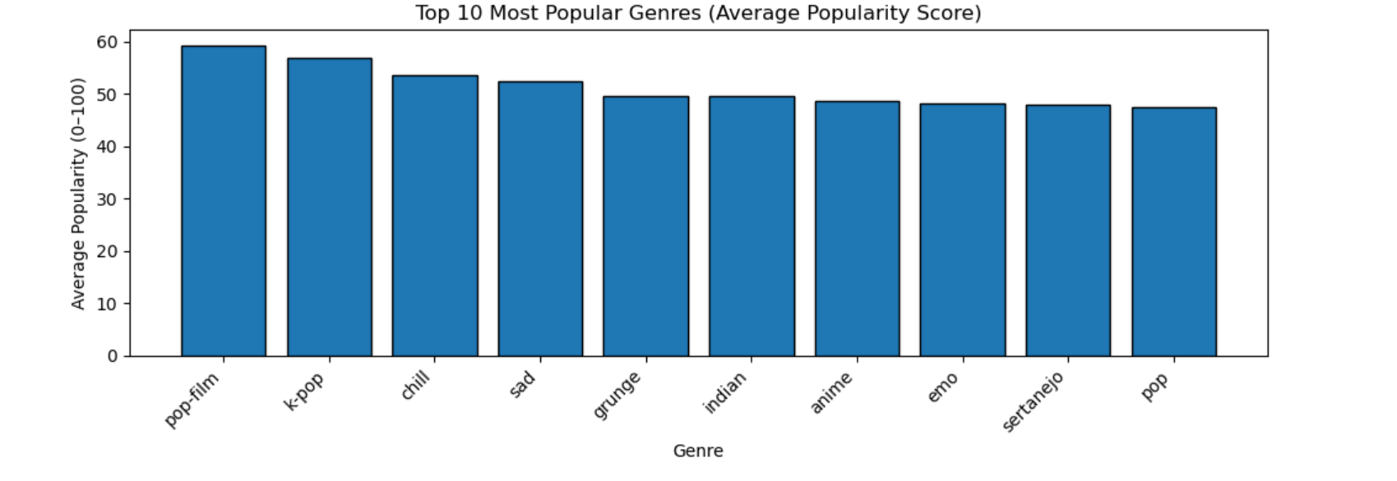

Interpretation

The results suggests that cultural significance and emotional resonance might be more important than musical complexities. Genres associated with movies, moods, or cultural movements typically do better. From a strategic standpoint, this reinforces Spotify's emphasis on mood-based playlists and editorial curation, which can foster long-term engagement better than genre-only discovery.

Q3. Is there a direct relationship between danceability and popularity?
Visualization: Scatter Plot of Danceability vs Popularity
Plotting danceability against popularity, this scatter plot shows thousands of music. The general spread does not exhibit a clear linear relationship, while songs with greater popularity tend to cluster around moderate to high danceability scores.

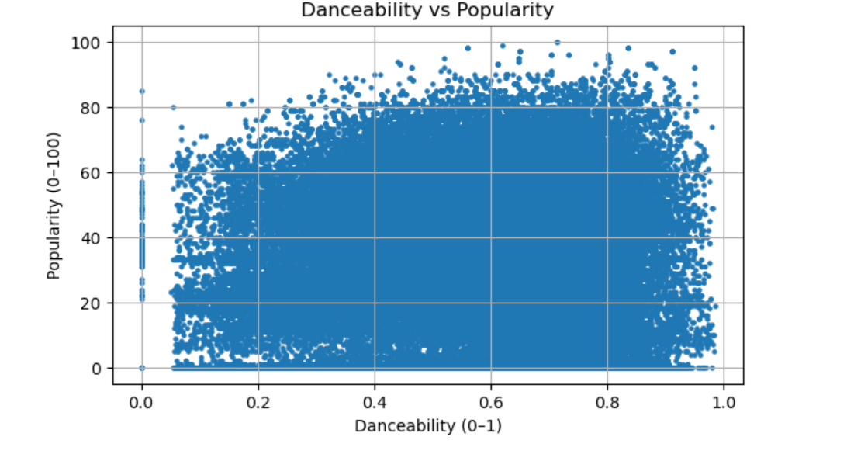
Interpretation

This suggests that success is not assured by danceability alone. There are well-known songs with a variety of danceability scores. This highlights the significance of multi-factor recommendation systems for business strategy that take into account not only auditory characteristics but also emotional tone, artist identification, cultural trends, and listener behavior.

Q4. Does song length influence popularity?
Visualization: Average Popularity by Song Duration Band
This chart analyzes the average popularity of songs that are divided into duration bands. On average, songs that are 3.5 to 5 minutes long do the best; songs that are very short or very long get lower popularity rankings.

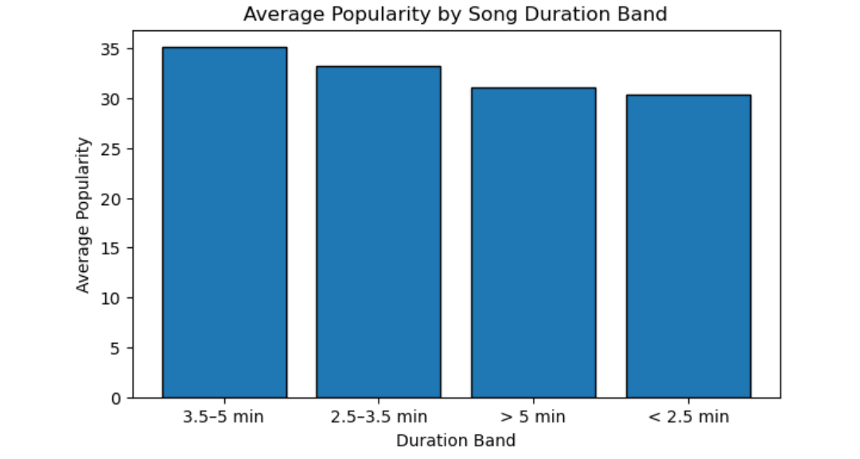

Interpretation

The graph depicts the need of a "sweet spot" for song length in the business that strikes a balance between replay value and audience attention. From a strategic perspective, this knowledge may direct playlist sequencing, artist suggestions, and even platform nudges for creators. This also helps promote formats that have traditionally done better with listeners.
Q5. What emotional moods dominate Spotify’s music catalog?

Visualization: Distribution of Valence (Mood) Across Tracks

The histogram demonstrates that there are fewer songs at the emotional extremes (extremely sad or very happy) in Spotify's music data, which is primarily centered in mid-range valence levels.

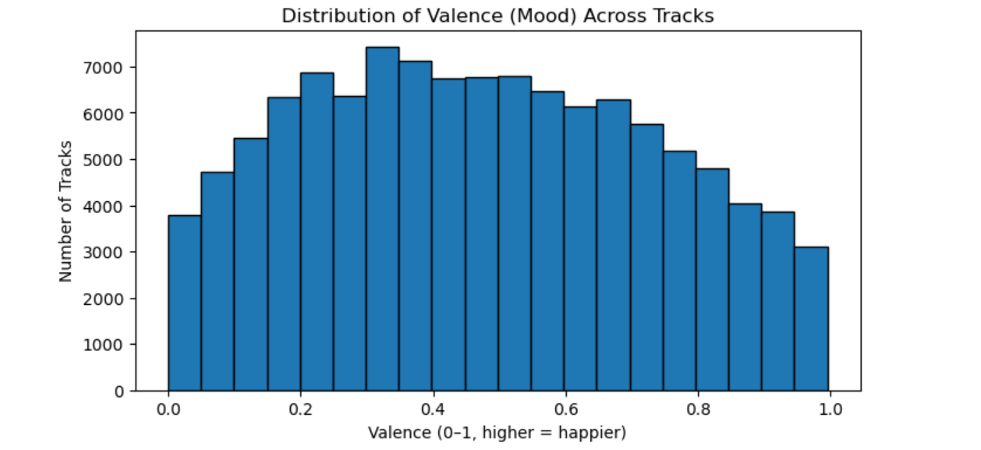

Interpretation

This highlights that the majority of music is in balanced or emotionally neutral states, probably because such songs are more adaptable to different listening situations. This helps Spotify to create a general-purpose playlists, like "Chill," "Focus," and "Daily Mix", that fit into daily routines rather than acute emotional situations.

Q6. Is music popularity evenly distributed across tracks?
Visualization: Pareto Curve – Cumulative Popularity Share
The Pareto curve demonstrates that a disproportionate fraction of overall popularity is accounted for by a comparatively small percentage of tracks. Cumulative popularity increases dramatically even among the top 20% of songs.

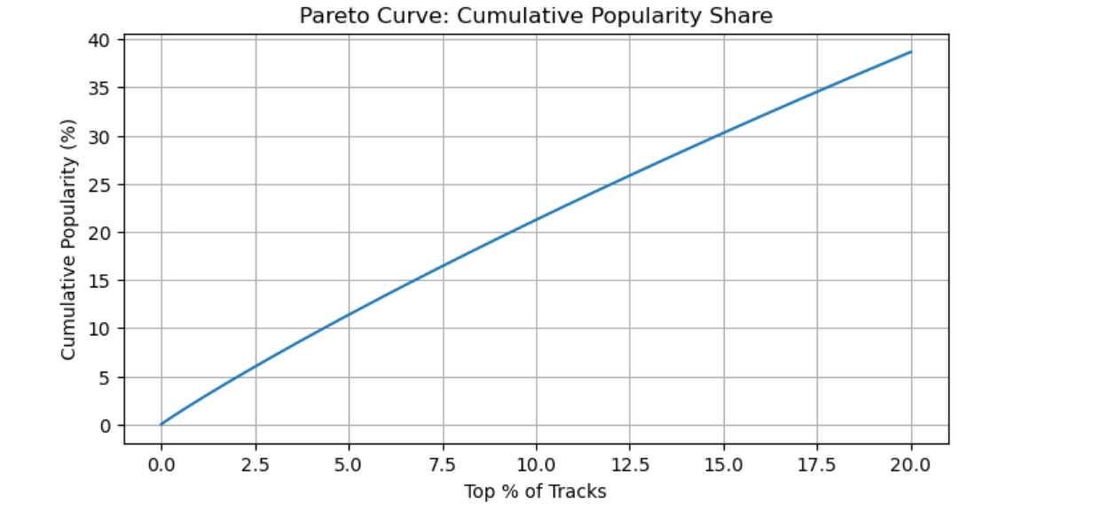

Interpretation

This validates the traditional streaming platform "winner-takes-most" dynamic. A significant amount of engagement is driven by a tiny selection of songs. In order to justify expenditures in customized suggestions and specialized playlists, Spotify needs strategically strike a balance between boosting breakout singles and making sure long-tail content is still discoverable.

Q7. Which mood profiles generate the highest popularity?
Visualization: Average Popularity by Mood Profile (Energy + Valence)
This graphic analyzes the average popularity of songs by classifying them into four mood profiles. Tracks categorized as "Chill / Moody" and "High energy / Moody" do better than profiles that are solely upbeat or joyful.

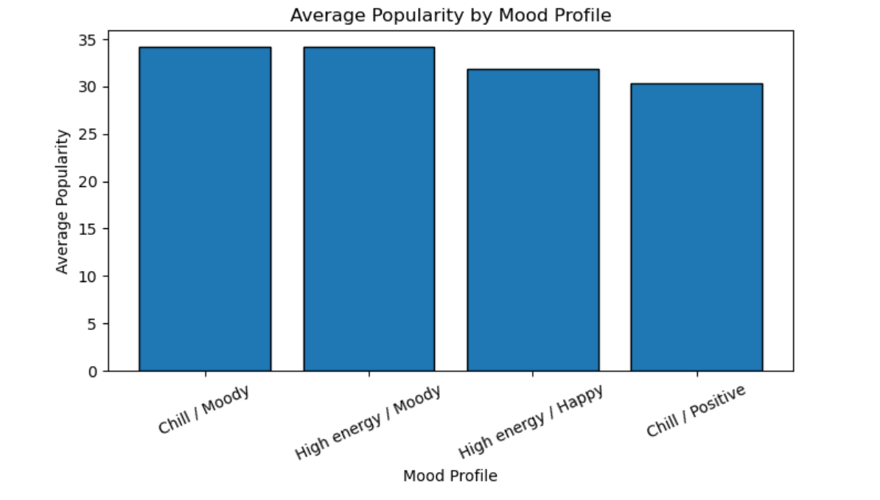

Interpretation

This suggests that listeners are drawn to music that is introspective or emotionally complicated rather than just cheerful. From a business standpoint, this realization validates Spotify's focus on emotionally charged playlists and narrative-driven advertising (like Wrapped), which link music to mood and individual identity.
Business Strategy
The analysis of Spotify’s track-level data reveals that listener engagement is shaped far more by emotional experience and context than by any single technical element. While features such as energy, danceability, tempo, and duration help describe a song, none of them alone could explain why certain tracks succeed. Instead, outcomes emerges from how these characteristics combine to fit specific listening moments in people’s daily lives.
One of the key takeaways from the analysis is the role of mood-driven listening. Genres and mood profiles associated with introspection, calmness, or emotional depth consistently show higher average popularity than purely upbeat or high-energy content. This suggests that listeners use Spotify more as a personal soundtrack for studying, commuting, relaxing, or processing emotion than using it as a party or performance platform. Looking from a business standpoint, this supports continued investment in mood-based playlists, personalized mixes, and recommendation systems that emphasixe emotional relevance over rigid genre classification.
The duration analysis provides another crucial insight. Compared to very short or long recordings, songs in the 3.5–5 minute range consistently perform better. When it comes to music streaming, Spotify users still prefer a more conventional listening experience, even with the growth of short-form content on sites like TikTok. This affects Spotify's creative assistance tools in addition to artists and labels. It might be possible to increase engagement without directly restricting artistic freedom by encouraging artists to create songs that suit this ideal length.
The Pareto analysis draws attention to a well-known yet crucial fact: despite Spotify's vast collection, attention is still dispersed unevenly. A significant portion of the overall popularity is captured by a very small number of songs. However, Spotify's long-tail structure demonstrates that many lesser-known songs continue to garner significant engagement, in contrast to platforms where attention is highly concentrated. This emphasizes how crucial customization algorithms are. Spotify should continue to concentrate on customized discovery pathways that enable specialty content to surface for the appropriate audience rather than pushing the same hits to every user.
Analyzing genres also reveals that global and culturally specific genres such as K-pop, pop-film, and chill outperform more traditional categories. This points towards a shift in how audience see relevant choices. Cultural context, storytelling, and emotional association has a larger role than genre labels alone. Strategically, this helps Spotify to explore opportunities to further localize content while still maintaining global reach through regional playlists and culturally driven promotions.

References

OpenAI. (2025). ChatGPT (October 2025 version) [Large language model]. Used for coding assistance and data visualization guidance in Python. https://chat.openai.com
Project Jupyter. (2015). Jupyter Notebook [Computer software]. https://jupyter.org
Source 1:
Econsultancy – “Six Insightful Data Storytelling Case Studies”
https://econsultancy.com/six-insightful-data-storytelling-case-studies/

Source 2:
Kaggle – Spotify Tracks Dataset:
https://www.kaggle.com/datasets/maharshipandya/-spotify-tracks-dataset

